User Manual

Aariya Singh

ST10029788

PROG6212

POE Part 3

Contents

Introduction 2

Purpose 2

Target 2

Requirements 2

Basic Navigation 2

Dashboard 2

Logging In 3

Register 4

Home Page 4

Logging Out 5

Semester 5

Module Page 8

# Introduction

## Purpose

The Module Calculator is designed to help users manage their academic modules efficiently. It provides tools for setting study plans, allocating study hours, and viewing important reminders related to each module.

## Target

The application is intended for students and individuals managing multiple academic modules or courses. It is also built with the purpose to aid users who struggle to manage their time efficiently.

## Requirements

A web browser is required to view the application. The source code can be found on the GitHub link provided.

# Basic Navigation

Registration

To use the Module Calculator, users must register for an account. Follow these steps:

1. Navigate to the registration page.
2. Provide the required information.
3. Confirm your password

Logging In

Once registered, follow these steps to log in:

1. Go to the login page.
2. Enter your email and password.
3. Click "Log In."

# Dashboard

Navigation

* The dashboard provides quick links to essential features.
* Use the navigation menu to access different sections of the application.

User Profile

* Click on your profile to view and update personal information.
* Change your password and manage account settings.

Reminders

* Receive reminders about upcoming study sessions or module-related events.

# Logging In

This is the first page a user will see when using the website. The rest of the website cannot be accessed without logging in first, and the Log In screen will be displayed throughout the web page if the user is not logged in.

Your registered email and password can be used to log in. The user will be logged in after clicking the Log In button.

Clicking the ‘Forgotten Password’ text box will allow the user to change their password by entering their email address.

Clicking ‘Register as new User’ will allow a user to create a profile for themselves in order to access the website and save their data.

# Register

This screen is accessed by clicking the ‘Register as new user’ text in the Log In screen. This screen allows a user to create a new account.

The user can enter a valid email, as well as a unique password for themselves. The password must be entered twice and match.

The password must contain both uppercase and lowercase letters, numbers and at least one special character.

Clicking the ‘register’ button allows the user to complete their profile. After this they can log in and access their data.

# Home Page

This page contains the welcome statement as well as the option to view a reminder for a module.

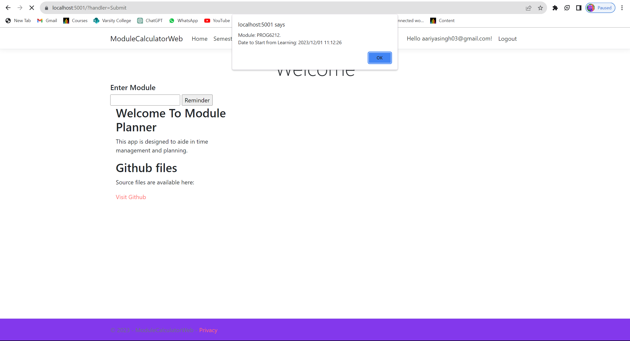

# Logging Out

This option is presented to the user at the top right of their screen. This allows them to end the session. Once the user logs out, the following page will be displayed to confirm that they have logged out successfully.

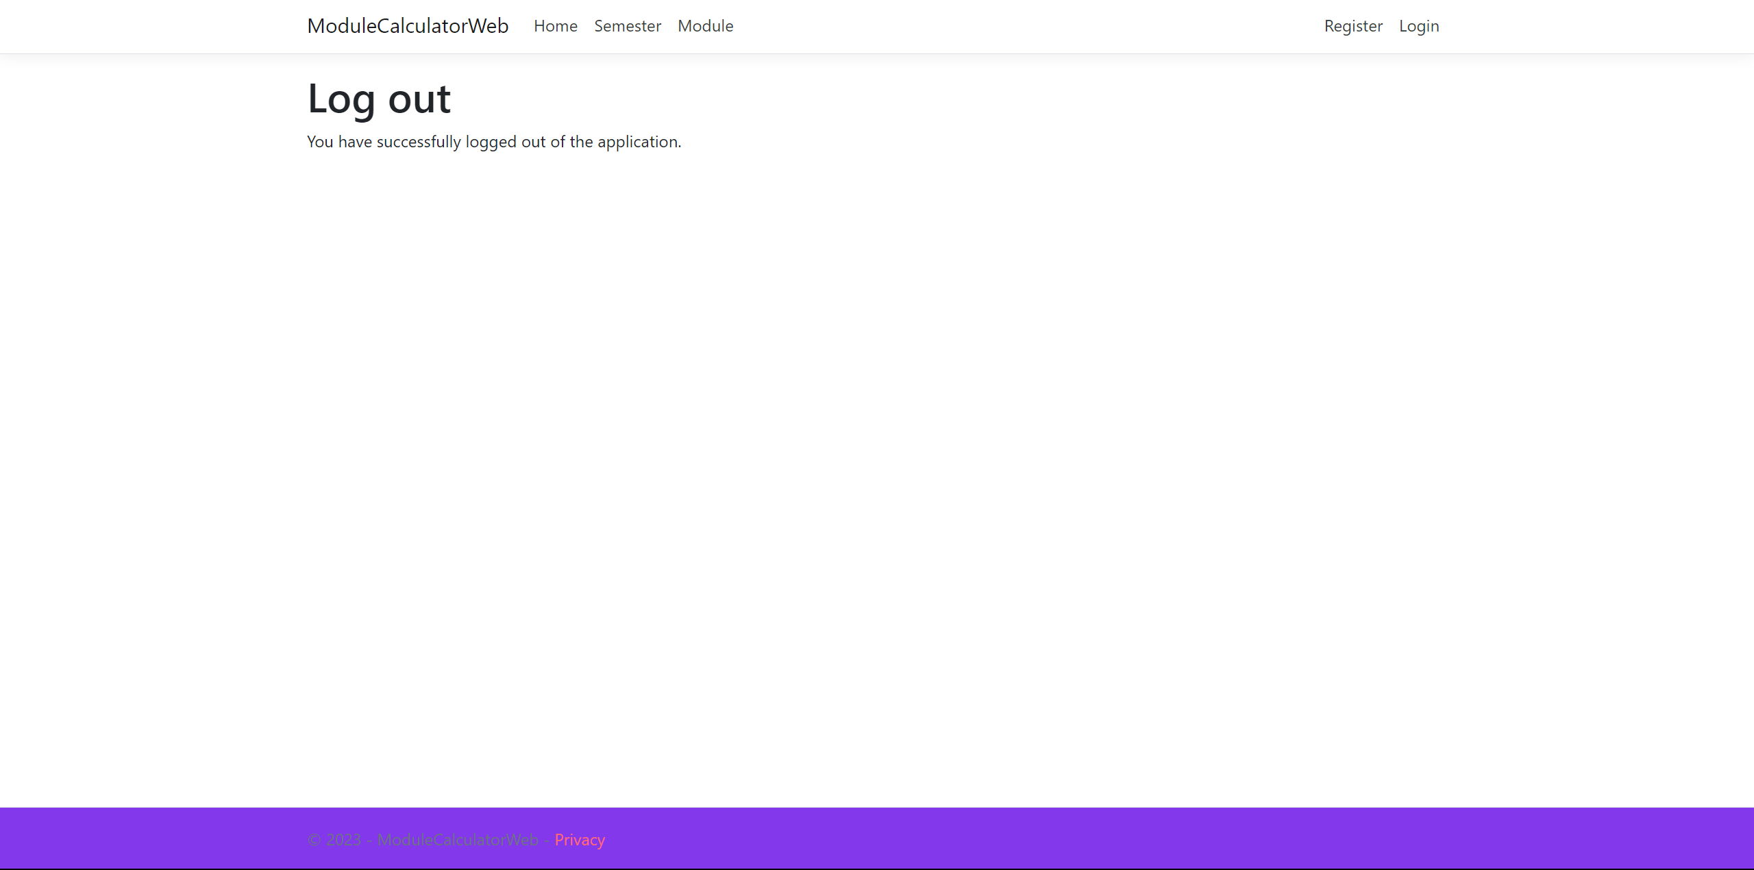

# Semester

The page will show a list of semesters. You also have the option of adding a semester using Create New.

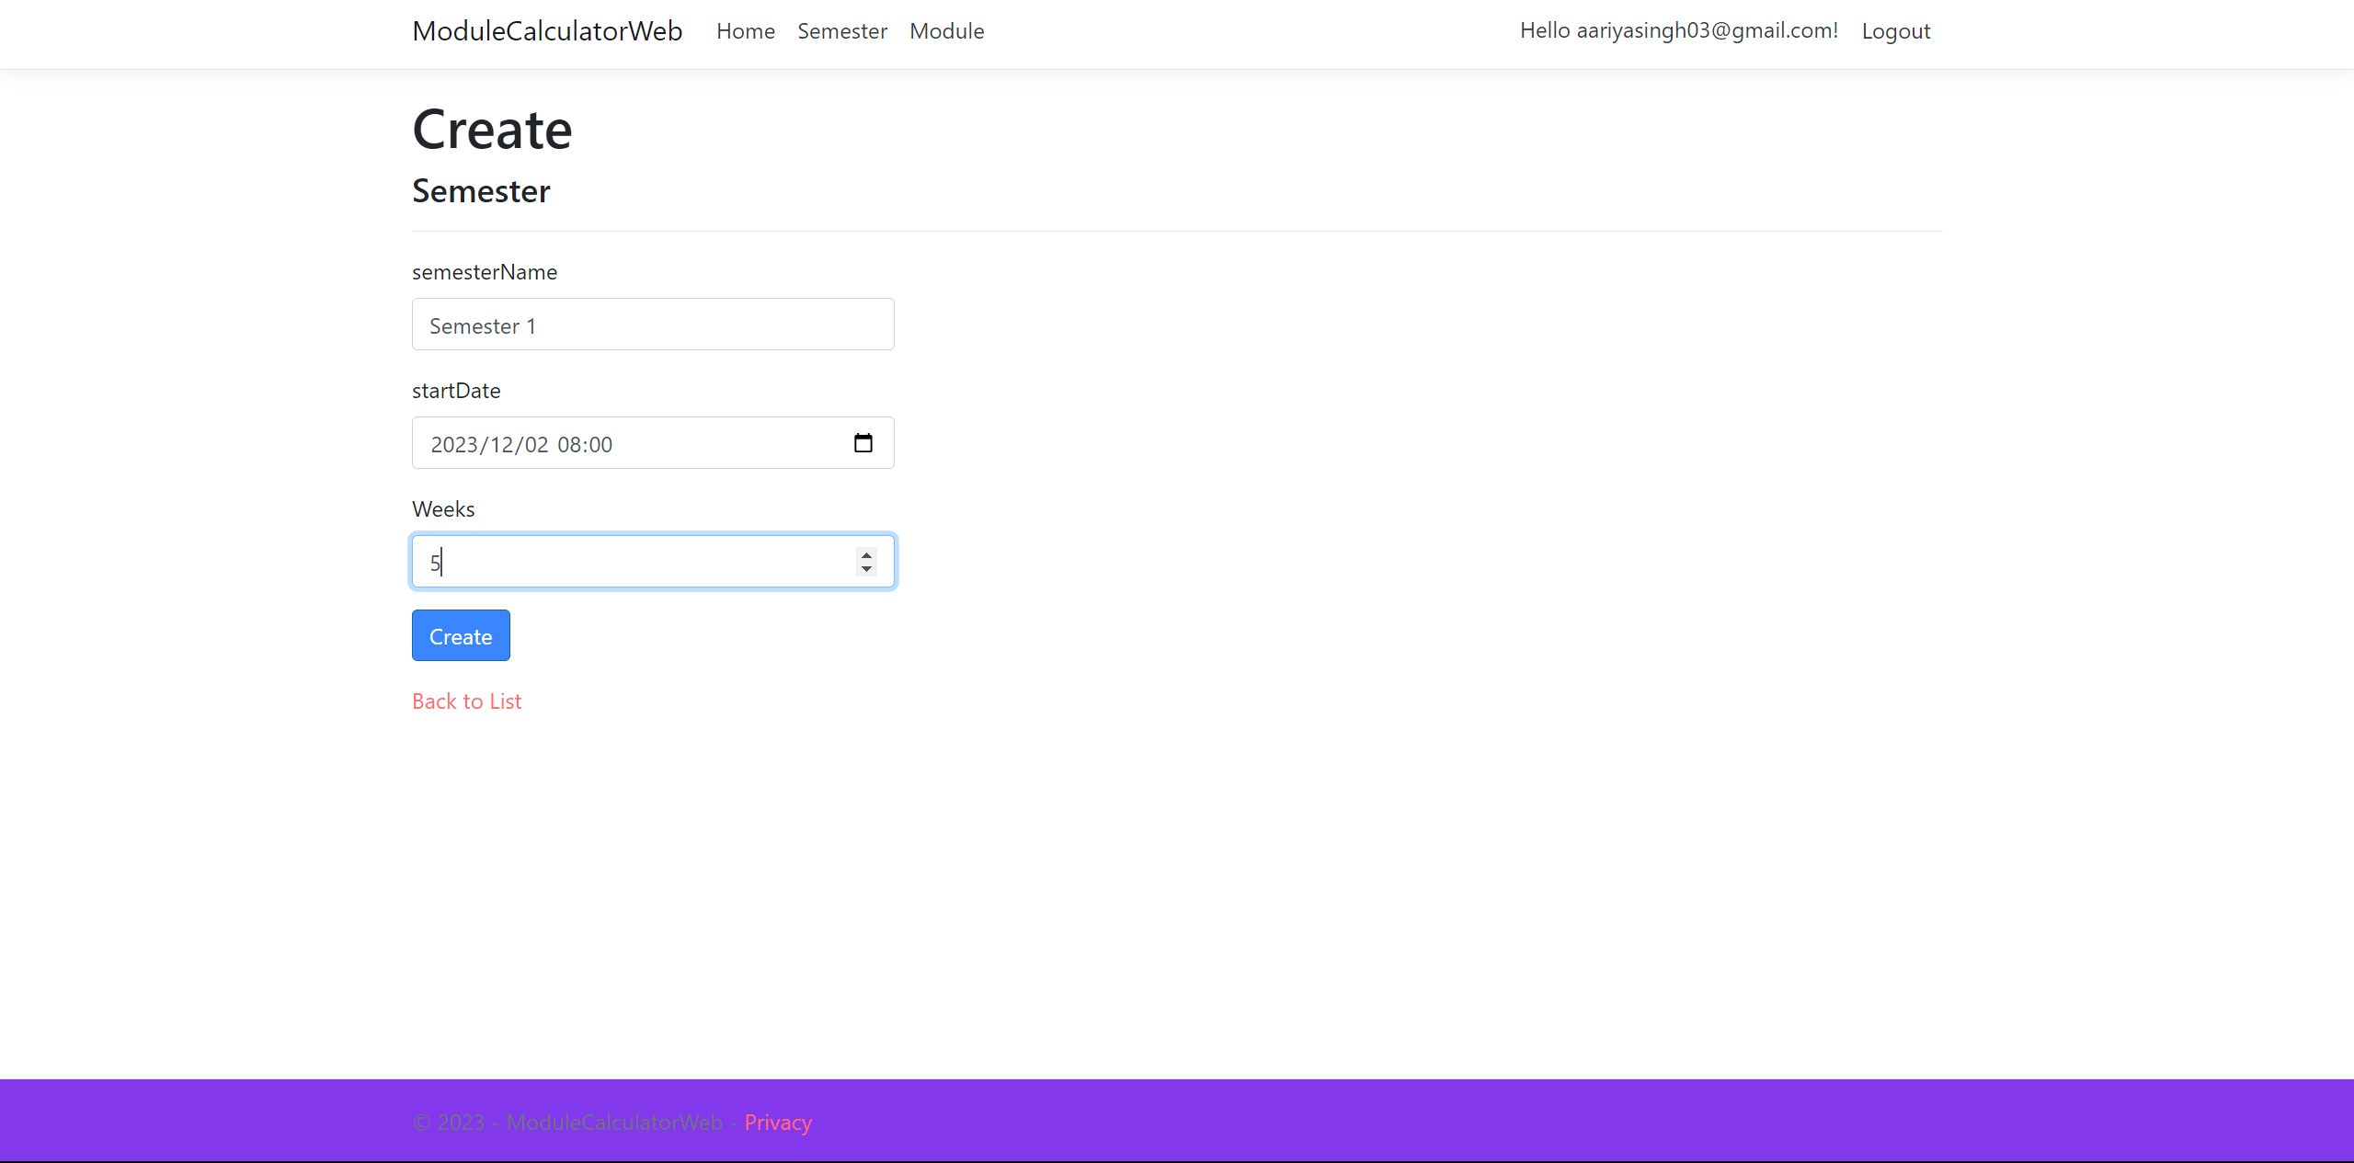

Once a semester has been added, you can view, edit and delete the details of the semester, using the corresponding buttons to save changed made.

# Module Page

This page will show the user details pertaining to any modules they currently take. It gives them the option to create a new module as well.

Once a Module is created, you can Edit, View details or delete using the corresponding text.